**LAKSHMI NARAIN COLLEGE OF**

**TECHNOLOGY**

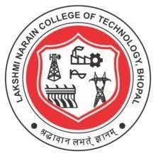

Mini Project / Internship Presentation

BT-307

Food Ordering Website

***Session-2023-2024***

**Submitted By: 119 - Mohammad Luqman,**

**120 - Mohd Zaki Ur Rahman Khan,**

**159 - Riya Nagwani**

**Branch: CSE – IOT & CS**

**Semester: III**

**Submitted To: Prof. Rajni Kori**

**Section: B**